CompuDance Software
Express Connect Guide for Parents to stay...

CompuDance, LLC 99 W. Madison Ave Dumont, NJ 07628

Thank you for joining In the Loop Studio Membership! This Portal will allow you to keep up to date with your schedule of classes, class Attendance, view your open and paid invoices, pay an invoice online, securely store your payment information for future use plus subscribe to get email and/or text alerts for events such as emergency school closings and holidays.

The first step is to register online from your school’s website. If you are already enrolled in classes at the school, you must contact your school admin to get a login and password.

To Register​ Online clicking from your school’s website will bring you right to the screen on Page 3. If you click from the CompuDance website you will be directed to this page:

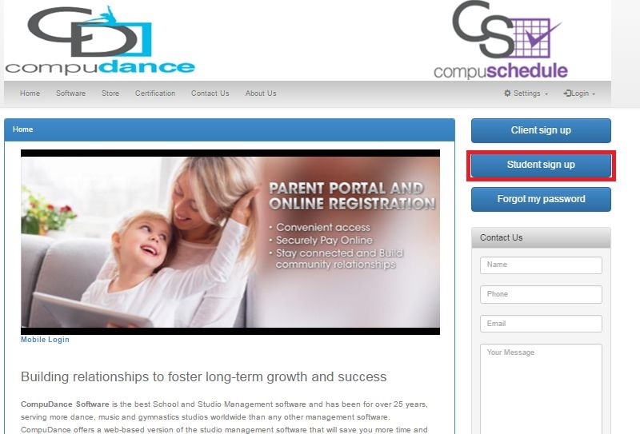

When you click on “Student Sign Up” below screen will appear:
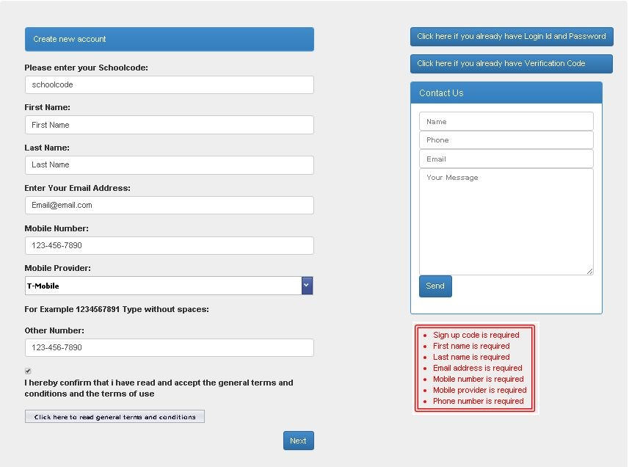

After clicking “Next”​ the “Verification​ Page” will display. You will receive a “Verification​ Code” to​ the “Mobile​ Number” you​ provided as long as you typed it correctly and chose the correct provider. If you did not, please check the email you provided as the verification code will also be sent to your “Email”​ .​

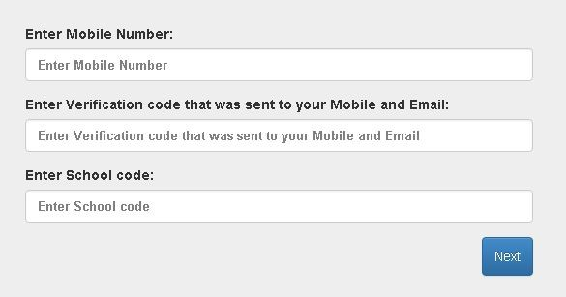

The Student Detail page will display:

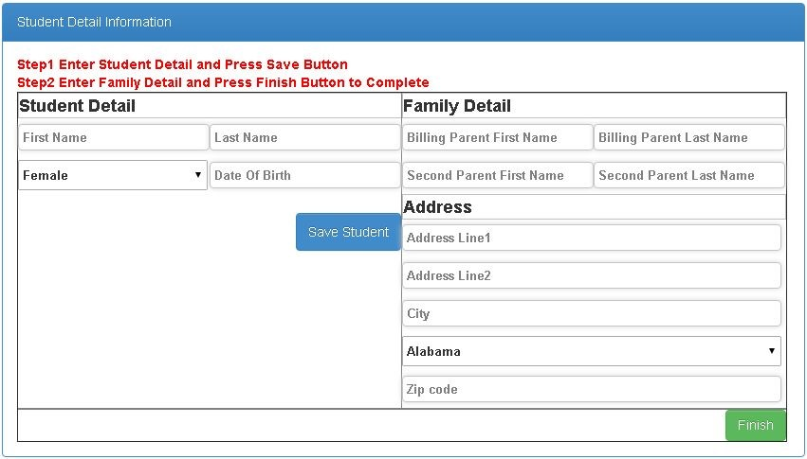

Once you complete the initial registration process you will receive an email with your temporary password and link to access the Parent​ Portal.​ When you are logged in, you will see a screen similar to this with your Student​ and Guardian​ information. If you made any mistakes in the registration process you can ​ Edit​ here.​

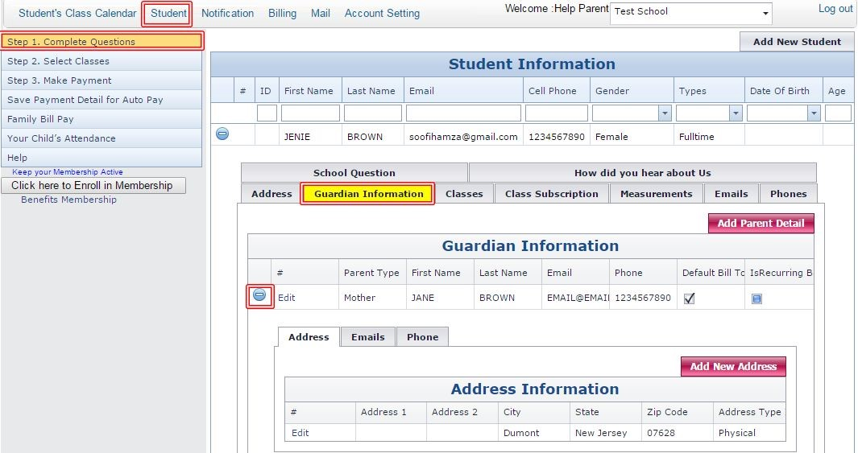
To select classes click on Student​ and then press ​ Select Classes​ the following window will pop up:​

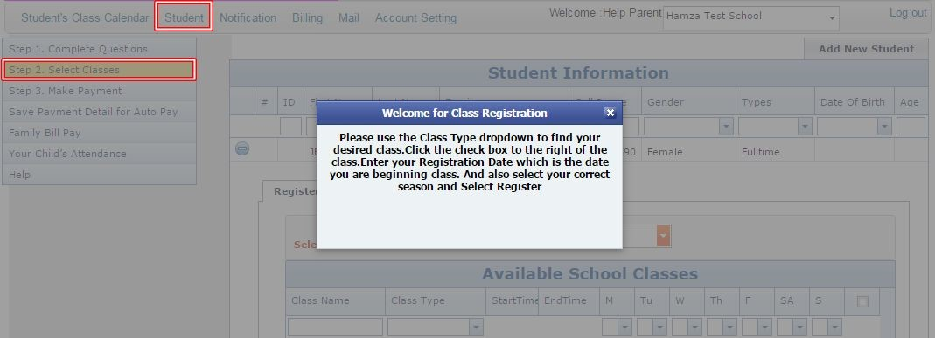

When you close above screen the following page will appear. Select​ Season and then check mark on your select Class​ or Classes.​ Utilize​ the search options at the top of the page to find the class or classes you are looking for. Searches are available by Class​ Name and​ Class Type.​ ​Once you find the class or classes click the check box on the right. Enter your Enrollment Date​ on the bottom and ​ Click Register​ .​

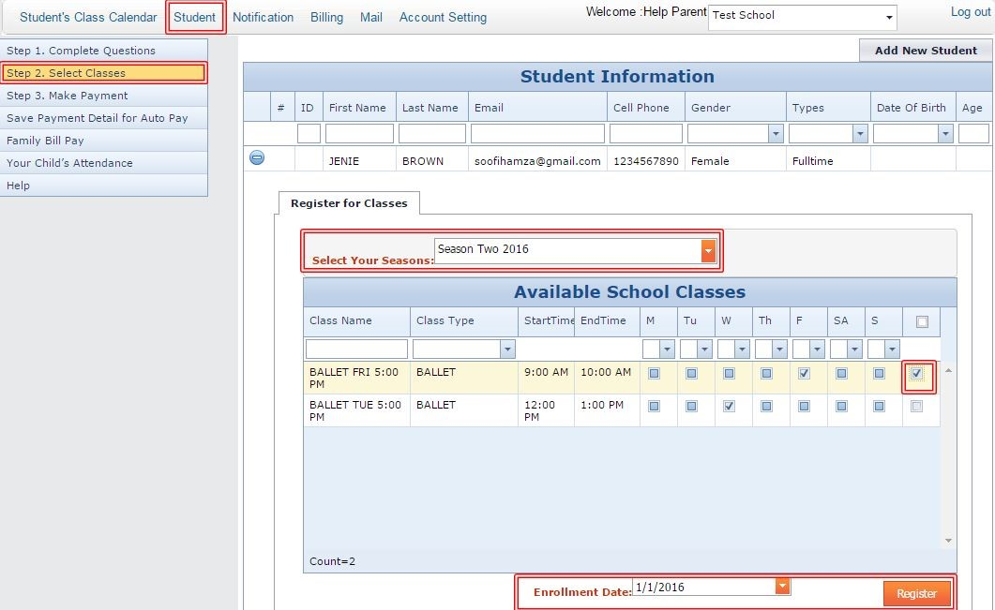

After selecting Classes​ your school may require payment to be made in order to secure your registration in class. If your school requires payment, an Invoice will be generated that you can pay for at this time. To make a payment click on Pay Full​ :​

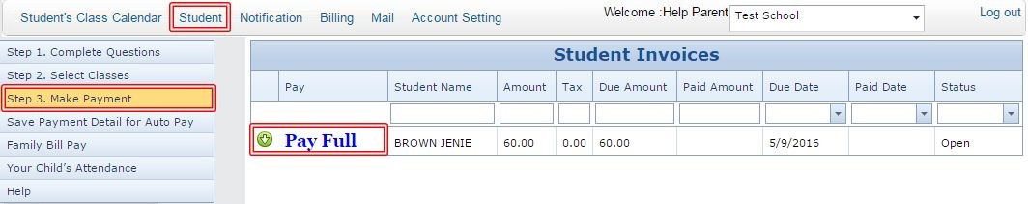

When you click on Pay Full​ . You have 2 choices for payment. First option is ​ Pay With Checking Account​ :​

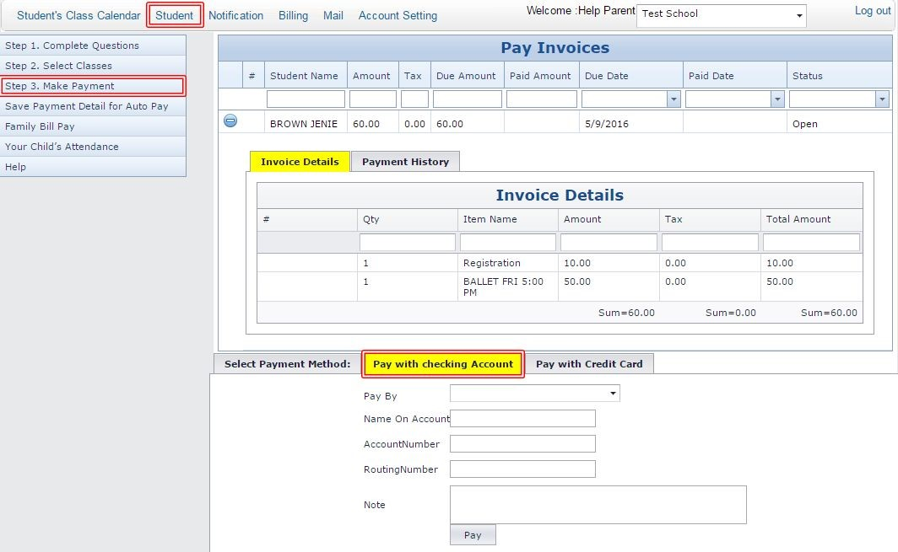

Second option is Pay With Credit Card​ :​

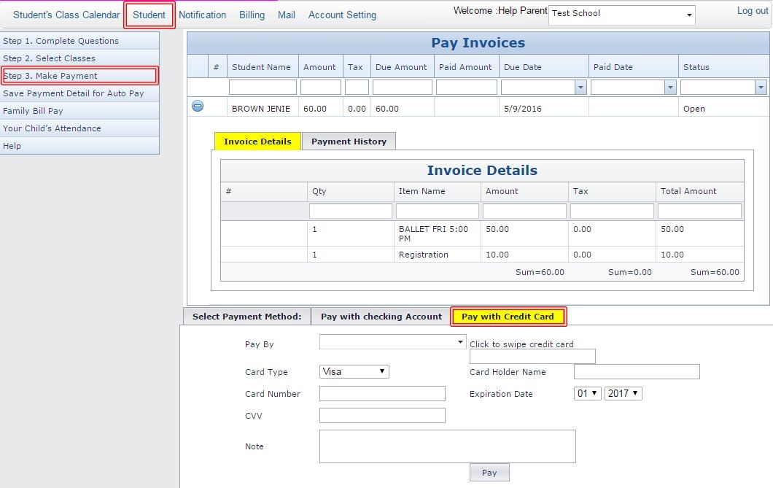

To save your payment information for future “Auto Pay” by the school or future payments to be made by the school click on “Save Payment Detail for Auto Pay”. You can save by ​ACH Family Account

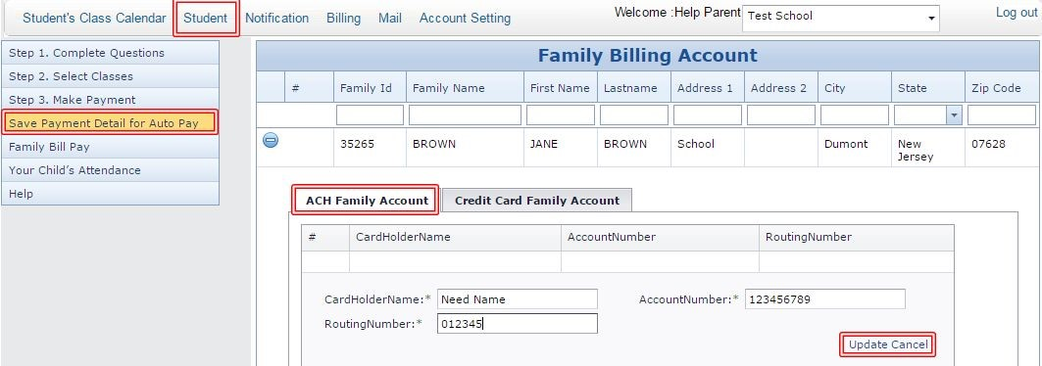

You can also save by ​Credit Card Family Account

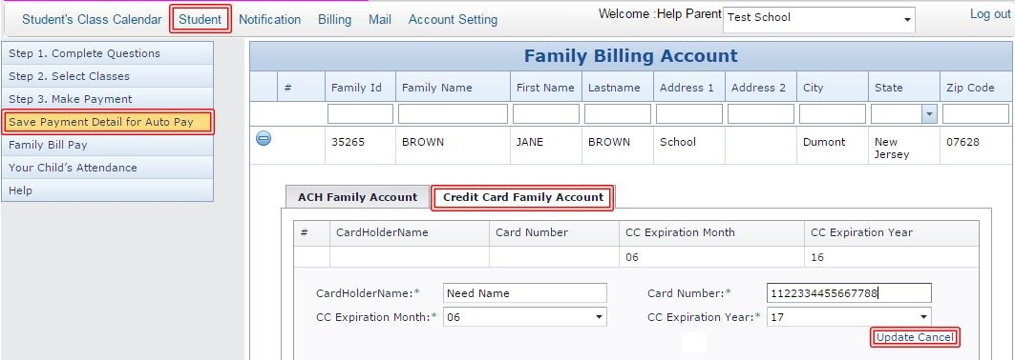

When you click on Family​ Bill Pay you have multiple choices of payments. You can pay tuition in one shot for your all kid.

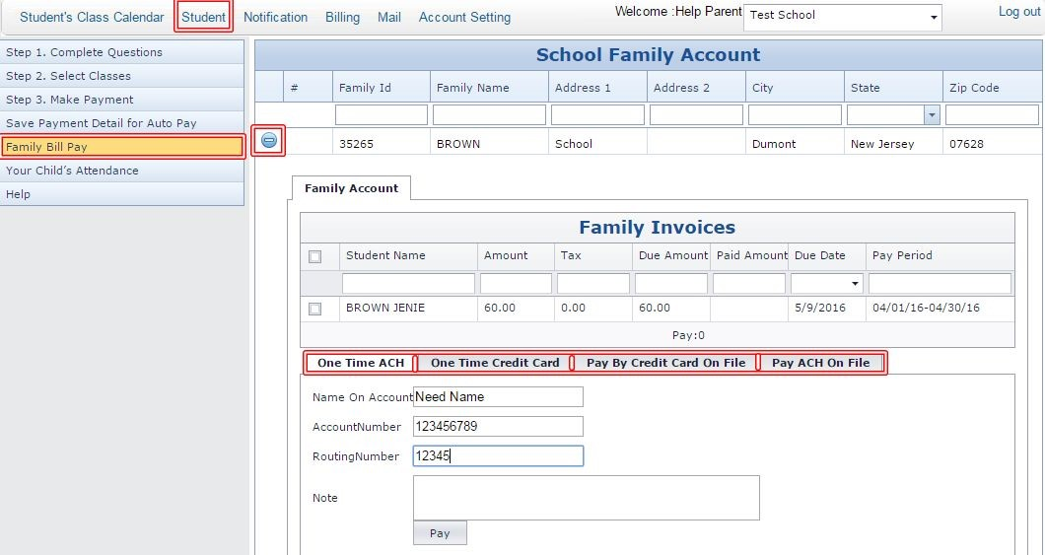

If you click on Your Child’s Attendance​

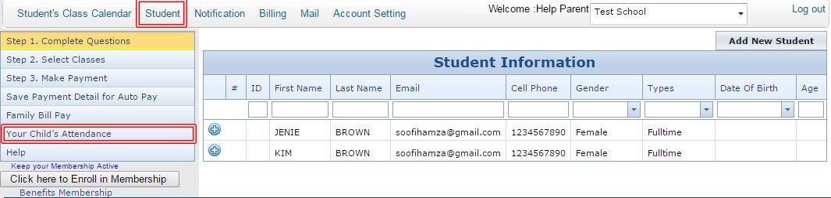
Following window will open right click on selected class and press ​Attendance​ button.

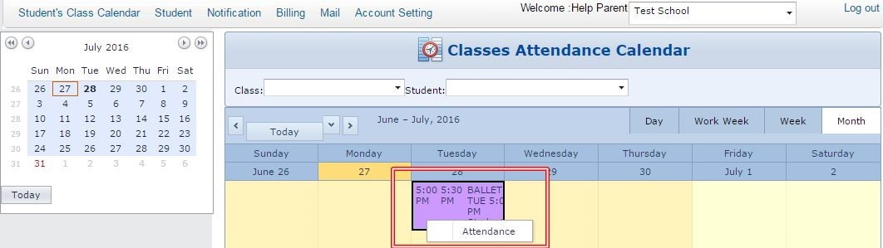

A new window will appear. You can see your child attendance here.

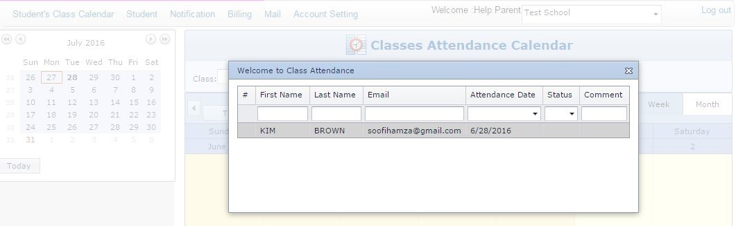

To change your password click ​Account Setting at the top and select ​Reset password your ​New Password must contain password have to be 6 to 20 characters string

- At least ​One Digit numeric.​
- At least “​One Uppercase​ letter.

● One Lowercase​ letter and One Special Symbol @#$%.​
● Only ​Special Characters @#$% ​are allowed.

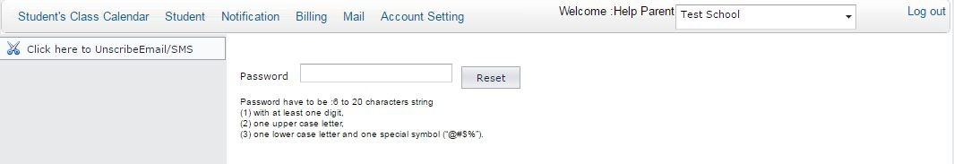

To view your Schedule on the calendar click home page go to the month you are beginning class and you will see your schedule listed right on the calendar.

